Title: Implementation of a Dynamic Web Application using Node.js, Express, JSON and AJAX.

The Municipal Corporation wants to upgrade the existing Smart City Information Portal from a browser-based website into a dynamic web application. The portal should run through a web server and provide citizens with current Public Transport Information whenever requested.

Enhance the existing Smart City Information Portal to:
1 | Configure the existing Smart City Information Portal to run through a local web server.
2 | Organize the application so that webpage resources and server-side processing are maintained appropriately.
3 | Provide suitable routes to access the Home and Public Transport Information sections.
4 | Maintain information about City Bus, Metro, Electric Bus and City Shuttle in a structured key–value data format.
5 | For each transport service, maintain Transport Name, Route, Starting Point, Destination, Fare and Availability.
6 | Make the transport information available from the server whenever requested by the webpage.
7 | Provide a “Load Transport Information” option for citizens.
8 | Retrieve the transport information from the server without reloading the complete webpage.
9 | Process the received information and display the available transport services inside the existing webpage.
10 | Allow a citizen to select a transport service and view its corresponding route, starting point, destination, fare and availability.
11 | Display a suitable message if the requested transport information cannot be obtained from the server.

Aim: To convert the existing Smart City Information Portal into a Node.js and Express-based web application and dynamically exchange JSON data between the server and webpage using AJAX.

MEAN Stack

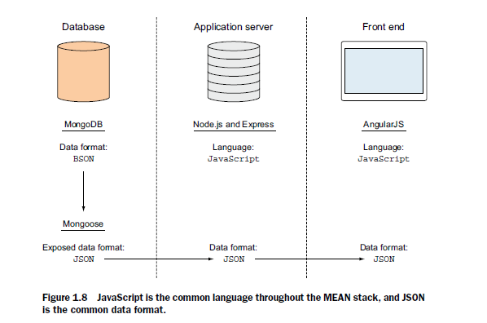

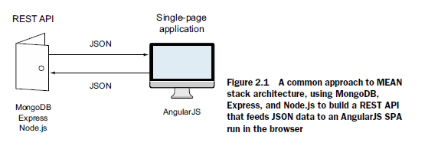

Role | Framework Used
Frontend (Angular) | Uses HTML, CSS, and JavaScript (TypeScript).
Backend (Express + Node.js) | Uses JavaScript to serve HTML, respond to API requests.
Database (MongoDB) | Stores app data, works with JSON-like documents.

11. (a). Create and run a basic Node.js web server that displays “Hello World”.

1. To check if it's installed:

node -v

npm -v

2: Create Project Folder

Create a folder for your project:

mkdir 01_mean

cd 01_mean

3: Create a JavaScript file

You need a JavaScript file to write your server code:

app.js

Or just create a new file named app.js in your code editor.

4: Write Server Code in app.js

Open app.js and write the following code step-by-step.

const http = require('http');
const port = process.env.PORT || 3000;

const server = http.createServer((req, res) => {
res.end('Hello World');
});

server.listen(port, '127.0.0.1', () => {
console.log(`Server is running on ${port}`);
});

5: Run the Server

In the terminal (make sure you're inside your project folder):

node app.js

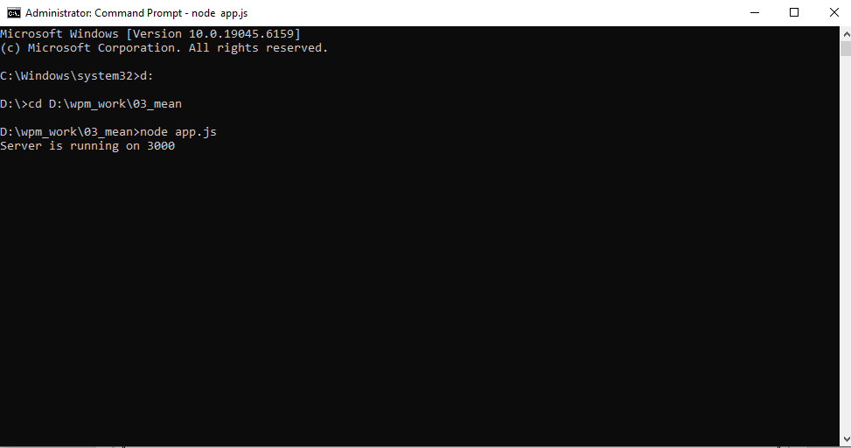

6: View the Result

Open your browser and go to:

http://localhost:3000

Output:

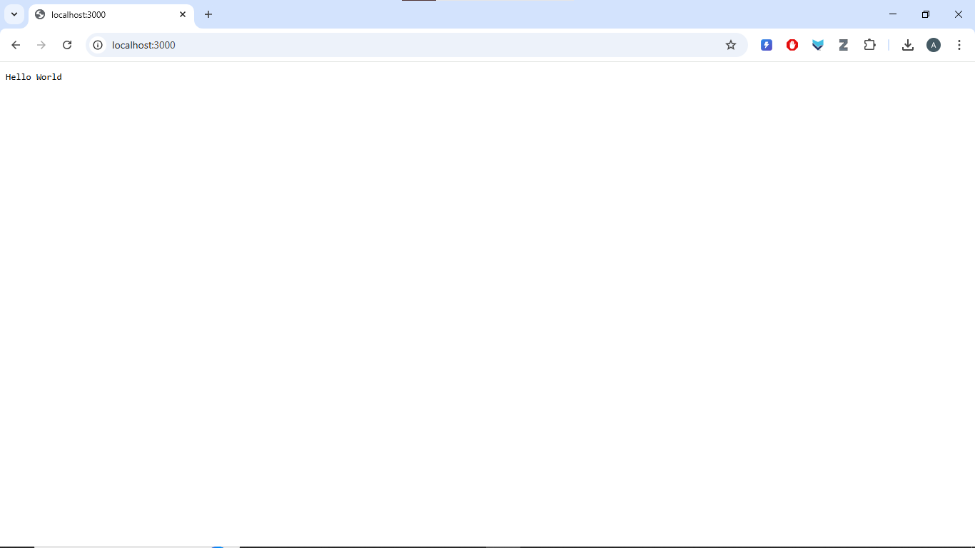

(b). Create and run a basic web application using Node.js and Express.

1: Initialize Express.js.

Open terminal in your project folder (node-webserver), and run:

npm init -y

This creates a basic package.json file.

2: Install Express Generator Globally

This tool enables you to quickly scaffold Express apps.

npm install -g express-generator

3: Install Dependencies

Navigate into your project folder:

cd 01_mean
express

npm install

This installs all packages listed in package.json (like express, ejs, etc.).

4: Run the Express Server

npm start

Output:

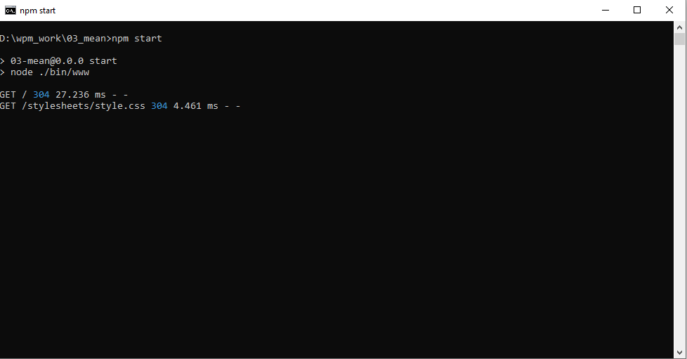

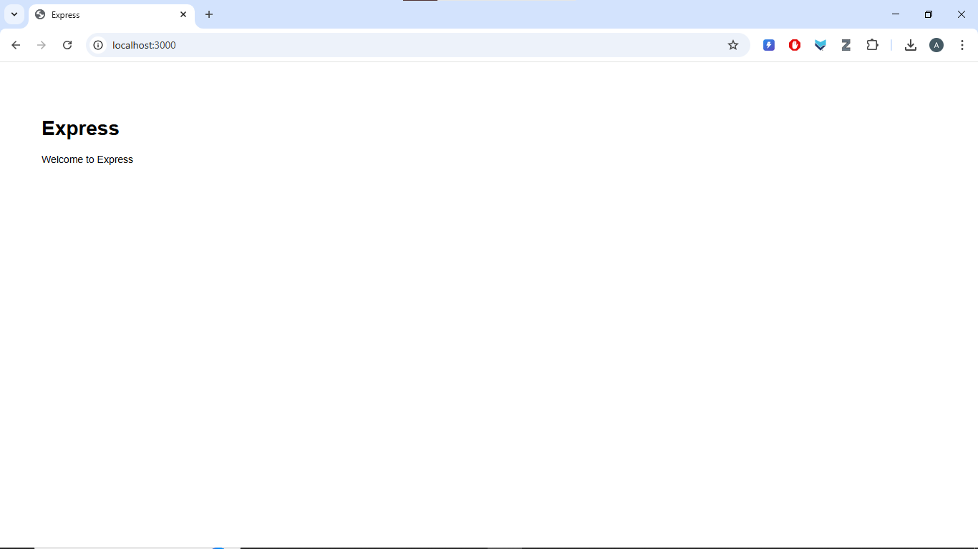

(c). STEP-BY-STEP: Deploy a Local Project to GitHub

1: Initialize Git in Your Project Folder
Open Command Prompt or terminal in your project folder:

cd D:\ewp_work\01_appserver

git init

git add README.md

git commit -m "first commit"

git branch -M main

git remote add origin https://github.com/avinashpallidlaan/01_mean.git

git push -u origin main

if getting an error uploading

Delete the .git file

git init

git add .

git commit -m "Initial commit"

git branch -M main

git remote add origin https://github.com/avinashpallidlaan/01_mean.git

git push -u origin main

SmartCity/
│
├── app.js
├── package.json
├── package-lock.json
├── node_modules/
│
└── public/
├── index.html
├── style.css
└── script.js

mkdir SmartCity
cd SmartCity
npm init -y
npm install express

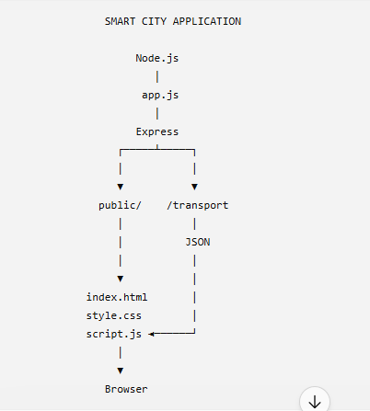

1. index.html

2. style.css

3. script.js

/* ======================================================
SMART CITY INFORMATION PORTAL
CLIENT-SIDE JAVASCRIPT
WEEKS 7 - 11
====================================================== */

/* ======================================================
WEEK 7
JAVASCRIPT FUNDAMENTALS AND CONTROL STATEMENTS
====================================================== */

// Existing Week 7 functionality
// Variables
// Data types
// Operators
// if...else
// loops

// Example:
// City service charge / eligibility / category logic
// developed during Week 7 remains here.

/* ======================================================
WEEK 8
FUNCTIONS, ARRAYS, OBJECTS, DOM AND EVENTS
====================================================== */

// Existing Week 8 functions remain here.

// Example structure:

const cityServices = [
{
name: "Hospital",
contact: "108"
},
{
name: "Police Station",
contact: "100"
},
{
name: "Fire Station",
contact: "101"
}
];

function showService() {

let selected =
document.getElementById("serviceSelect").value;

let output = "";

for (let i = 0; i < cityServices.length; i++) {

if (cityServices[i].name == selected) {

output =
"<h3>" +
cityServices[i].name +
"</h3>" +

"<p>Contact: " +
cityServices[i].contact +
"</p>";
}
}

document.getElementById(
"serviceResult"
).innerHTML = output;
}

/* ======================================================
WEEK 9
ADVANCED JAVASCRIPT
VALIDATION + DATE + MATH + LOCAL STORAGE
====================================================== */

function registerComplaint() {

try {

let citizenName =
document.getElementById(
"citizenName"
).value.trim();

let mobile =
document.getElementById(
"mobile"
).value.trim();

let category =
document.getElementById(
"category"
).value;

if (citizenName == "" ||
mobile == "" ||
category == "") {

throw "Please complete all details.";
}

if (mobile.length != 10 ||
isNaN(mobile)) {

throw "Enter a valid 10-digit mobile number.";
}

let complaintNumber =
Math.floor(
Math.random() * 10000
);

let complaintID =
"CMP" + complaintNumber;

let today =
new Date();

let complaintDate =
today.getDate() + "/" +
(today.getMonth() + 1) + "/" +
today.getFullYear();

localStorage.setItem(
"citizenName",
citizenName
);

localStorage.setItem(
"complaintID",
complaintID
);

localStorage.setItem(
"complaintCategory",
category
);

document.getElementById(
"complaintResult"
).innerHTML =

"<h3>Complaint Registered</h3>" +

"<p>Complaint ID: " +
complaintID +
"</p>" +

"<p>Date: " +
complaintDate +
"</p>";

}

catch (error) {

document.getElementById(
"complaintResult"
).innerHTML = error;

}
}

/* View complaint saved in localStorage */

function viewComplaint() {

let citizenName =
localStorage.getItem(
"citizenName"
);

let complaintID =
localStorage.getItem(
"complaintID"
);

let category =
localStorage.getItem(
"complaintCategory"
);

if (complaintID == null) {

document.getElementById(
"complaintResult"
).innerHTML =
"No saved complaint found.";

}

else {

document.getElementById(
"complaintResult"
).innerHTML =

"<h3>Saved Complaint</h3>" +

"<p>Citizen: " +
citizenName +
"</p>" +

"<p>Complaint ID: " +
complaintID +
"</p>" +

"<p>Category: " +
category +
"</p>";
}
}

/* ======================================================
WEEK 10
XML + AJAX
EMERGENCY INFORMATION
====================================================== */

function loadEmergency() {

let xhttp =
new XMLHttpRequest();

xhttp.onreadystatechange =
function () {

if (this.readyState == 4 &&
this.status == 200) {

let xml =
this.responseXML;

let services =
xml.getElementsByTagName(
"service"
);

let output = "";

for (let i = 0;
i < services.length;
i++) {

let name =
services[i]
.getElementsByTagName(
"name"
)[0]
.textContent;

let location =
services[i]
.getElementsByTagName(
"location"
)[0]
.textContent;

let contact =
services[i]
.getElementsByTagName(
"contact"
)[0]
.textContent;

output +=

"<h3>" +
name +
"</h3>" +

"<p>Location: " +
location +
"</p>" +

"<p>Contact: " +
contact +
"</p>";

}

document.getElementById(
"emergencyResult"
).innerHTML =
output;

}

};

xhttp.open(
"GET",
"emergency.xml",
true
);

xhttp.send();

}

/* ======================================================
WEEK 11
NODE.JS + EXPRESS + JSON + AJAX
PUBLIC TRANSPORT INFORMATION
====================================================== */

/* Store JSON information received from server */

let transportData = [];

function loadTransport() {

let xhttp =
new XMLHttpRequest();

document.getElementById(
"transportMessage"
).innerHTML =
"Loading transport information...";

xhttp.onreadystatechange =
function () {

if (this.readyState == 4) {

if (this.status == 200) {

try {

/*
Convert JSON response
into JavaScript objects
*/

transportData =
JSON.parse(
this.responseText
);

let transportSelect =
document.getElementById(
"transportSelect"
);

transportSelect.innerHTML =
'<option value="">' +
'-- Select Transport --' +
'</option>';

/*
Create dropdown options
using server information
*/

for (let i = 0;
i < transportData.length;
i++) {

let option =
document.createElement(
"option"
);

option.value = i;

option.textContent =
transportData[i].name;

transportSelect.appendChild(
option
);

}

transportSelect.disabled =
false;

document.getElementById(
"transportMessage"
).innerHTML =
"Transport information loaded successfully.";

}

catch (error) {

document.getElementById(
"transportMessage"
).innerHTML =
"Unable to process transport information.";

}

}

else {

document.getElementById(
"transportMessage"
).innerHTML =
"Unable to obtain transport information from the server.";

}

}

};

/*
Request JSON from Express server
*/

xhttp.open(
"GET",
"/api/transport",
true
);

xhttp.send();

}

/* Display selected transport */

function showTransport() {

let selected =
document.getElementById(
"transportSelect"
).value;

if (selected == "") {

document.getElementById(
"transportResult"
).innerHTML =
"Please select a transport service.";

return;

}

let transport =
transportData[selected];

let availability;

if (transport.available == true) {

availability =
"Available";

}

else {

availability =
"Not Available";

}

document.getElementById(
"transportResult"
).innerHTML =

"<h3>" +
transport.name +
"</h3>" +

"<p><strong>Route:</strong> " +
transport.route +
"</p>" +

"<p><strong>Starting Point:</strong> " +
transport.start +
"</p>" +

"<p><strong>Destination:</strong> " +
transport.destination +
"</p>" +

"<p><strong>Fare:</strong> ₹" +
transport.fare +
"</p>" +

"<p><strong>Availability:</strong> " +
availability +
"</p>";

}
4. app.js
const express = require("express");
const path = require("path");

const app = express();

// Serve the existing Smart City website
app.use(express.static("public"));

// Home Route
app.get("/", function (req, res) {

res.sendFile(
path.join(
__dirname,
"public",
"index.html"
)
);

});

// Public Transport Page Route
app.get("/transport", function (req, res) {

res.sendFile(
path.join(
__dirname,
"public",
"transport.html"
)
);

});

// Public Transport Data

const transports = [

{
name: "City Bus",
route: "Route 101",
start: "Central Bus Station",
destination: "Railway Station",
fare: 20,
available: true
},

{
name: "Metro",
route: "Blue Line",
start: "City Centre",
destination: "Airport",
fare: 40,
available: true
},

{
name: "Electric Bus",
route: "E-20",
start: "Municipal Office",
destination: "University",
fare: 25,
available: false
},

{
name: "City Shuttle",
route: "S-10",
start: "Railway Station",
destination: "Bus Terminal",
fare: 15,
available: true
}

];

// JSON Data Route
app.get("/api/transport", function (req, res) {

res.json(transports);

});

// Start Server
app.listen(3000, function () {

console.log(
"Smart City Portal running at http://localhost:3000"
);

});

http://localhost:3000/transport

